Project: Woodson Park Academy & YMCA-ELC
Week Ending: October 11th, 2019

THIS WEEK:
- Foundations wall pours
- Pour north side footer
- Storm line install continued
- Waterproofing of foundation wall continues
- Pour upper level piers
- Set pole for Temp power

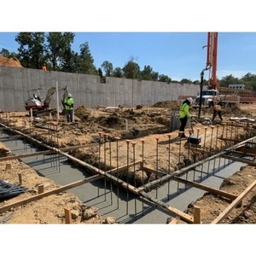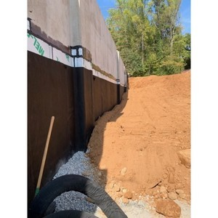

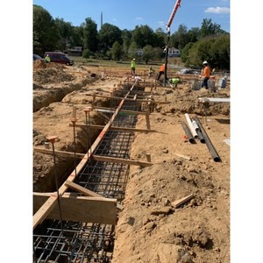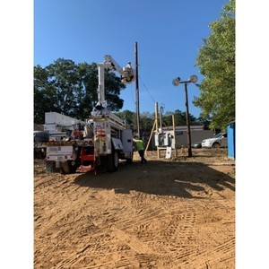

NEXT WEEK – October 14 thru October 18:
- Foundation wall
- Storm line install
- Cutting of NE parking lot grade
- Waterproofing
- Upper level peirs

PAYMENT STATUS:
- Gmp#1 $3,703,488.00
  - Paid to date amount $646,892.85
- GMP#2 $28,686,295.00
  - Paid to date amount $0.00

SCHEDULED DATE OF SUBSTANTIAL COMPLETION
- WPA – September 28, 2020
- YMCA-ELC - September 16, 2020

PREPARED BY:
- Matt Dauber, Carroll Daniel Construction Co.

